Site Review
BlueHost.com
Starting journey in 1996, BlueHost.com boasts of hosting a whooping 165,000 domains across the globe. Its feathers in the crown include such awards as, Host of the Year 2005-Hosting-Review.com, Host of the Year 2005 - Hosting-Review.com, 2005 Web Host of the Year - 100best-web-hosting.com, BlueHost Review - Hosting-Review.com, Best Support 2004 - 100best-web-hosting.com to name a few.
Price Value 9/10
Performance 9.5 / 10
Reliability 9.5 / 10
Customer Support 9.5 / 10
Control Panel 9 / 10
User Feedback 9.5 / 10
Overall Grade: 93%

Top Pick
If you are thinking of launching your own sites, or shifting your existing sites to a new host, you can take a look at this. The mouth watering offerings of Bluehost.com include such attractive features as:
- Free Domain Name, or setup
- Content Package
- Promotional Package
- Free eCommerce/Cart
- Free Blog, Chat, Boards
- $50 Free to use on Yahoo Search Marketing; and
- Top Notch 24/7 Support
No wonder, with such power packed features included; competing with BlueHost.com is not a piece of cake for other hosting sites.
Value for money
At $6.95 a month BlueHost.com offers free setup, free domain name registration, 15 GB disk space, and up to 6 domain name registrations absolutely free! That’s not all. You also get $50 worth of Yahoo Search Marketing benefits FREE! As if that is not enough, you are also loaded with such goodies as the absolutely new Free Drag & Drop Site Builder feature, support international domain names feature, 2,500 POP3/POP3 secure email support., 3 different web based email solutions, unlimited forwarding email accounts, 400GB/mo Gigs of site transfer (now more), account control panel, PHP, Pearl 5, Python, Ruby, guestbook, live chat, message forum, image gallery, blog feature, poll & survey software, web auction software.
Multimedia features include--supporting streaming audio / video, real audio / video support, Flash support, Macromedia Shockwave, MIDI file support, and adding own MIME types.
E-commerce features include: SSL Secure Server, OS Commerce Shopping Cart, Agora Shopping Cart, Cube Cart Shopping Cart, Zen Cart Shopping Cart, Free Generated Certificate, Password Protected Directories, OpenPGP / GPG Encryption
Besides, site promotion support like; search engine submission, search keyword analyzer and search engine position report, are provided totally free, as a friendly gesture.
Affiliate Program.
You can earn almost ten times as much as you pay for your monthly subscription, by joining the affiliate program of BlueHost.com. For each referral they pay you $65, which is not bad at all! All you have to do is place their banner ad at a visible position of your site (takes a minute-copy and paste the javascript). You can keep track of who is clicking the banner ad placed on your site and being a member of BlueHost.com.
Customer Support
Excellent 24 X 7 customer support and sales support by their 24 hrs toll free call centre and online customer support centre are some of the factors which made BlkueHost so popular today. BlueHost believes their customers are important to them. In addition to offering customers the best hosting at the cheapest prices, BlueHost also provides superior customer service. If their online Help Center doesn't answer your questions, give them a call toll free in these numbers: (888) 401-HOST, (888) 401-4678
Their billing support & affiliate business development support departments are operational Monday through Friday 8AM to 5PM.
Reliability
Reliability is the key to success on the internet. With BlueHost’s high quality redundant systems you can be sure that your data is always available for both you and your customers. Quad processor performance servers, denial of Service Protection (DDOS), UPS Power Backup, diesel generator backup power, customized apache web Server, 24/7 network monitoring, mirrored storage backups, OC-48 backbone connection are some of the reliability features of this Orem, UT based hosting giant. Here is their address:
BlueHost Inc.
1548 North Technology Way #D13
Orem, UT 84097
To sum up; these are the reliability factors which you can consider to choose BlueHost as your host.
- Highest customer service
- Quality equipment
- Maximum guaranteed uptime
- Highly functional tools for administration
- The leading feature set available
- Secure and reliable backups
- Solid and honest business.
IPOWER : a site review
IPOWER, with a 500,000 members gigantic base offers a host of web hosting solutions. Members of IPOWER can run upto 10 domains having 1 web hosting account. with IPOWER has struck a hat-trick by winning the award ‘Web Host of the Year’, by 100best, in the years 2002, 2003, and 2004. IPOWER offers their members a wide range of options to choose from;
- Free domain name
- 10 GB of space / 2,500 Email Accounts
- Marketing / content package
- Host 6 websites in 1
- Up to $100 in free advertising credits .
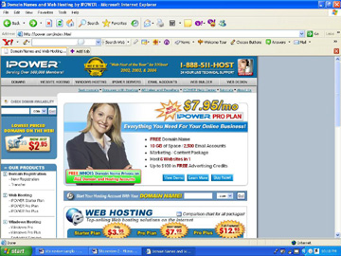

Our ratings
Price Value 9/ 10
Performance 9.5 / 10
Reliability 9.5 / 10
Customer Support 9.5 / 10
Control Panel 9 / 10
User Feedback 9.5 / 10

Top Pick
IPOWER offers one of the lowest monthly hosting fees; as low as $ 3.95 (for the starter plan) IPOWER makes your Windows Hosting choice easy, with free inexpensive setup, unlimited emails (in Pro Plus), SSL / CGI / PHP / MySQL, online support & 24/7/365 call center support, web designing support and lots more. All for competitive prices offering range. Choose according to your requirement and budget.

Price Value
IPOWER’s basic ‘Starter Plan’ comes at a shoestring monthly hosting cost of just $3.95/mo, with features like 3 Gigabytes / 1 Email; 50 GB of bandwidth; domains starting at $2.95, 1 MySQL database, blog and gallery software, and easy-to-use tools. Their second hosting plan ‘Pro’, at $7.97/mo (IPOWER’s bestseller) offers such features as: 10 GB / 2,500 Emails, 250 GB of bandwidth, 1 FREE domain name, SSL / CGI / PHP / MySQL , e-commerce enabled, marketing / content package, $30 Google credit, $50 Yahoo credit, website builder & templates, host 6 domains in 1. The 3rd and most powerful hosting option, known as ‘Pro Plus’ offers, at $12.95/mo, such wonderful features as: 15 GB / Unlimited Emails, 500 GB of bandwidth, 3 FREE domain names, SSL / CGI / PHP / MySQL, e-commerce enabled marketing / content package, $30 Google credit, $50 Yahoo credit, website builder & templates, host 10 domains in 1.
Developing on a Windows platform? IPOWER has some great Windows-based hosting solutions for you. Each package provides the necessary server-based technology support for web and non-web applications, including ASP.NET v1.1 support, SQL server 2000, ODBC access databases and SSL + CGI-BIN. ‘Windows Pro Plan’ starting from $9.95/mo , offering 10 Gigs / 500 emails, 1 FREE domain name, ASP & .Net 2.0 support, ODBC access, SSL + CGI-BIN, 5 MySQL Databases, website starters Plug-Ins, $30 Google credit, $50 Yahoo credit.
Windows ‘Pro Plus’ is available at $14.95/mo, wirth features like 20 Gigs / Unlimited Emails, 3 FREE Domain Names, ASP & .Net 2.0 Support, ODBC Access, SSL + CGI-BIN, 10 MySQL Databases, website starters Plug-Ins, $30 Google credit, $50 Yahoo credit.
Windows ‘Dedicated Servers’ are available if you can fork out $79.95/mo. You will receive features like Intel Celeron 2.4 GHz, 256 MB DDR RAM, 40 GB Hard-drive, 500 GB Transfer, ASP & .Net Support, ODBC Access Databases, Plesk 7.5 Control Panel, besides $30 Google credit, $50 Yahoo credit.
Your account comes with free features included, like blog software, photo gallery, online chat and message forum builder; plenty of online marketing tips & tutorials, besides a host of ecommerce features and unlimited POP3 emails, Power Plugins and Java Plugins.

IPOWER Affiliates
You can take the advantage of IPOWER’s Referral Program. Refer three clients for a Web hosting package and your Web hosting will be free for an entire year. Besides, IPOWER offers one of the most rewarding Affiliate Programs in the industry for Webmasters. Drive traffic to their website and receive $100 in commission for every new customer. The IPOWER Reseller Program is the most manageable and profitable Reseller Solution on the Web. IPOWER provides the Reseller Solution to hosting companies, consultants, Web designers and more.

Reliability
IPOWER gives a solid 30 day money back guarantee and stands behind a solid 99.9% uptime guarantee all the time. IPOWER presents a solid dedicated server offering, which allows you to focus on your business and leaves the network and server performance management to the experts. With IPOWER Dedicated Servers, you get to experience blazing speed, smart routing capability, state-of-the-art hardware and software, and performance monitoring of you IP services on our OC 192/OC-48 Backbone.
IPOWER's Internet Data Centers are strategically located on AT&T's, Global Crossing and Cable & Wireless' OC48 / OC192 Global IP backbones. These locations, together with the extensive public / private peering arrangements, are designed to maximize your Internet reach, bandwidth capacity and to optimize performance. UPS Backed with power back-up, diesel back-up generator, you will never see your site vanish from the net. To ensure your data's security, their facilities are staffed 24 hours a day with on-site guards and equipped with both interior and exterior closed circuit television.

Customer support
IPOWER offers 24/7/365 customer support in many convenient ways. Their call center number is (888) 511-4678. Besides calling, you can preferably have a live chat with their technical support personnel, and sales support team. Alternately, you can send your queries, and problems to them via email, which they reply shortly, via email route. Before that you can always check out the FAQ databank for questions and solutions, and maybe, you will find your solution then and there.

Site Review-3
Host Gator
Guess what happens when you cocktail an alligator, with a web host? It becomes Host Gator. The first thing that catches your eye in Host Gator site is a royal blue alligator (cartoon) eating up the ‘H’ of ‘Host Gator’. And when you start wondering what the significance of the name and the cartoon is; the slogan below hits your eye—‘we eat up the competition’. Cool! Self explained. Host Gator does have the ability to eat up the competition, especially in the reseller segment. They are the world's leading provider of reseller accounts with over 10,000 resellers who have chosen Host Gator to provide the network, servers, and support required to launch a hosting business.
Host Gator, hosting a mammoth figure of 200,000 domains, offers a variety of web hosting solutions. Members of Host Gator can run upto 10 domains having 1 web hosting account.Host Gator is the proud winner of awards like FindMyHost.com Editor’s Choice Award, Honest Host Award, Hosting Review Top Pick 2005, and a lot of more. Host Gator offers their members a wide range of options to choose from, with prices ranging from $6.95/mo to $374/mo.

Our ratings
Price Value 8 / 10
Performance 8.5 / 10
Reliability 8.5 / 10
Customer Support 8.5 / 10
Control Panel 8 / 10
User Feedback 9 / 10

Overall Grade: 84%

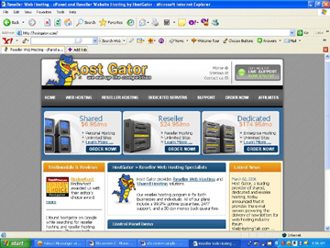
Top Pick
HostGator offers some of the best range of solutions for resellers to create their own pricing and packages. Their customer feedback has shown that support and reseller assistance is excellent.
Price Value
HostGator hosting plans start with Hatchling Plan for shared hosting at 3.5 GB space, 50 GB transfer rate @ $6.95/mo, for beginners, or for those, whose site requirements are limited. Host Gator however specializes in reseller hosting, but they also offer reasonably priced shared and dedicated server hosting plans. Host Gator Reseller Plans are offered for prices ranging from $24.95/mo to $99.9/mo, and their Dedicated Server Plans range from $174.00/mo to $374.00/mo. Also included in these packages are features like free set-up, unlimited MySQL databases, SpamAssasin software that will help reduce the amount of junk email received, and a 99.9% uptime, and a 30-day money-back guarantee.

Host Gator Affiliates
You can make money by referring people to Host Gator and for each member joining you can earn upto $125! Not bad, really!! The more members you sent, the higher is the rate.
Reliability
HostGator house their data center from The Planet, located in Dallas, Texas. The Planet boasts over 35,000 square feet of raised floor space, and features state-of-the-art security, safety, and cooling systems. This facility is accompanied with Multiple TXU electrical grids, 4800 volts of input power, DataTrax monitoring software for the whole data center infrastructure, and a fully meshed and redundant Certified Cisco Network featuring 10 backbone providers. Power back-up is provided by two powerful, heavy duty generators, to give their customers peace of mind regarding the security and reliability of their servers.

Control Panel
HostGator employs the industry standard control panel, CPanel, which is one of the best in the industry, having over 39 installable scripts. It is easy to use, as it provides more than one million end users the ability to install dozens of leading open source accompanied with flash movies for instant tutorials. Your package will also include Fantastico, the leading auto-installer for CPanel servers. Fantastico is equipped with more than 10,000 installations, and content management systems that a user can integrate into their web space swiftly.
Customer support
Host Gator offers 24 X 7 customer support in a number of convenient ways. Their call center number is 1-866-96-GATOR. Besides calling, you can preferably have a live chat with their technical support executive, and sales support team. Else, you can send your queries, and problems to them via email using their ticket system, which they reply shortly, by email. Before that you can always check out the FAQ databank for questions and solutions, and 99% chances are, you will find your solution there, and will have to look no further. If you enjoy flash tutorials, they have that option for you, as well. Besides all these ways to help you, their unique online community brings you face to face with other members, who might have your solution. Customer feedback about their support is very positive.
Hosting Plans
Linux/Unix Hosting Plans
Hatchling: 3.5 GB disk space, 50 GB bandwidth @ $6.95/month
Baby: 5 GB disk space, 75 GB bandwidth @ $9.95/month
Swamp: 10 GB disk space, 100 GB bandwidth @ $14.95/month
Semi-Dedicated: 25 GB disk space, 500 GB bandwidth @ $74.95/month

Site Review-4
STARTLOGIC
Trusted by over 50,000 satisfied customers, Its feathers in the crown include such awards as, Host of the Year 2005-Hosting-Review.com, Readers’ Choice 2005 by 100best-web-hosting.com, to name a few. They offer a 30 day money back guarantee, coupled with 99% uptime guarantee.
Price Value 9/10
Performance 9.5 / 10
Reliability 9.5 / 10
Customer Support 9.5 / 10
Control Panel 9 / 10
User Feedback 9.5 / 10
Overall Grade: 93%
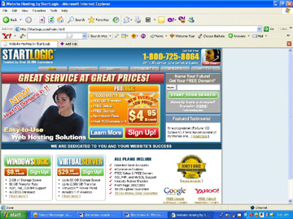
Top Pick
StartLogic include such attractive features as:
- Rates starting from $4.95/mo
- Host 10 domains in 1.
- Unlimited Email Accounts
- eCommerce Enabled
- FREE Setup & FREE Domain
- CGI, PHP, and MySQL Support
- 99.9% Uptime Guarantee
- 30 Day Money Back Guarantee
With such power packed features included; competing with StartLogic will not be child’s play for other hosting sites.
Value for money
At just $4.95/mo you can get StartLogic’s Pro Logic Pack having features as 15 GB storage, 500 GB transfer, free setup, free domain, hosting 10 domains in 1.
At $9.95/mo StartLogic offers their Windows Logic Pack with features like 2 GB of Storage Space, 60 GB Transfer Rate, ASP and .net Support, ACCESS Database.
Virtual Server is available at $29.95/mo accompanied with features as-- Up to 60 GB Storage Space, up to 2,000 GB transfer, Virtuozzo™ Power Panel, includes 1 IP address.
Dedicated Servers can be hired at $99/mo with features like-- upgradeable to 4 X 250 GB, SATA Disk Space, Up to 2 GB RAM, Up to 2,000 GB bandwidth.
Multimedia features include--supporting streaming audio / video, real audio / video support, Flash support, Macromedia Shockwave, MIDI file support, and adding own MIME types.
Promotional features include greatest promotional tools; get a 500+ page marketing manual, a search engine positioner and submitter, Meta Tags and Keywords Generators, a Link Checker, and $50 matching credit for advertising. In brief, a very very friendly hosting site, indeed.

Affiliate Program
(a) Affiliates:
If you are interested to make some additional income, join the Affiliate Program of StartLogic get $100 for every confirmed new buyer you send to StartLogic! StartLogic.com's affiliate program gives you all the tools you'll need to earn money!
- Web-based software for real-time reporting of your earnings
- Marketing center with lots of banners, buttons and text links to place on your site
- Lots of special offers and promotions to help you drive traffic
- Receive exclusive Affiliate-only deals on all our products
- Get paid monthly for every sale! No minimums to meet!
(b) Refer 3 friends and your hosting becomes free
Give your friends the chance to experience the StartLogic service. Once you refer three friends who become StartLogic customers, StartLogic will credit your account with 1 year of FREE service. It doesn't get much easier! Your friends will thank you, StartLogic will thank you, and your wallet will thank you!
Conditions
- The referred customer must purchase 1 year of service with StartLogic
- If a referring customer cancels his/her account, all remaining referral credits are forfeited.
- There is no limit on how many friends you can refer.
- The Referral Program may not be used in conjunction with any other offer.

(c) Be part of the multi BILLION dollar Web Hosting Industry
It's simpler than ever when you partner with StartLogic! Literally everyone is a potential customer. Every day, thousands of people sign up for a new web site or transfer their web site from an existing hosting company. Websites are used for just about every purchase—business, educational, family, and fun.
StartLogic provides you everything you need to get going quickly in this lucrative industry. Their Reseller Programs are completely private label. Your potential customers will never know that you have partnered with StartLogic. Their dedicated Reseller Support Team is available 24x7 to assist you every step of the way. If you are looking for a part-time or even full-time income that increases every year as your customer base grows, then we cannot think of a more secure proven industry than web site hosting.
If you are new to the web site hosting industry, or you are already a successful reseller and want to upgrade to a more reliable and stable firm and are looking to generate more revenue, you can consider getting in touch with StartLogic.
Customer Support
StartLogic offers 24/7 X 365 customer support in a number of customer friendly ways. Their toll free call center number is 1-800-725-8064. Besides calling, and talking to their technical support members, you can preferably have a live chat with their technical support executive, and sales support team, or send your queries, and problems to them via email using their ticket system, which they reply soon, by email. But before that you can check out the FAQ databank (Knowledgebase and Troubleshooter) for questions and solutions, and fair chances are, you will find your solution there, and will have to look no further. Besides all these ways to help you, their unique online community brings you face to face with other members, who might have your solution. You can get downloads of your choice too. Customer feedback about their support is positive.
Reliability
The StartLogic data center is located in Phoenix, Ariz., due to the city's protection from extreme climate. This area of the country is void of snow, earthquakes, landslides, and other extreme environmental conditions. In addition, Arizona is home to the world's largest power plant, ensuring a sufficient power supply. It provides the technology necessary to keep your website or server fully operational 24/7. The custom designed facility provides redundant optical fiber connections through Cox, Qwest, and ELI, in addition to multiple Internet back-bone providers, including UUNET, Broadwing, and Global Crossing, making scaling bandwidth faster and much more affordable.
Plus, their world-class data center is custom designed with raised floors, HVAC temperature control systems, redundant power, UPS back-up and power conditioning systems and generators. They provide 24/ 7 physical security; including state-of-the-art smoke detection and fire suppression systems, motion sensors, biometric access controls, as well as video surveillance and security breach alarms.
Depending upon equipment needs, clients can choose from Dedicated Servers, Locked Cabinets and Private Data Suites. Their 24/7 on-site systems management team comprised of Engineers and Technicians are on hand to ensure that the data center provides the reliability and scalability essential to your business success.
Here is their address:
For Postal Mail:
StartLogic, Inc.
919 E. Jefferson St, Suite #100
Phoenix, AZ 85034
For Legal Inquiries:
Christopher Gonzalez
General Counsel
111 E. Broadway, #210
Site Review-5
DOT 5 HOSTING
The clean, white and blue site at the first appearance, wins your confidence by the decent, neat appearance, (and the men and women they feature) and you feel like working with them. The several awards they have already won include Hosting Review Editor’s Pick 2006, FindMyHost, Editor’s choice 2004, and many more. 10 Gigabytes of Hosting Space, Host 5 Domains on 1 Account, 5000 Pop/Imap Email Accounts, Free Setup, Free Domain Forever and an attractive price tag of just $3.95/mo are some of the features they are offering.
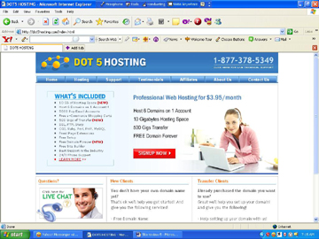
Our ratings
Price Value 9.5 / 10
Performance 8.5 / 10
Reliability 8.5 / 10
Customer Support 9 / 10
Control Panel 8.5 / 10
User Feedback 9/ 10
Overall Grade: 88%
Top Pick
90 days money back guarantee, quality hardware from brands like Dell, IBM, Intel Xenon, round the clock support, statistics generation, marketing help, e-commerce features, reliable connection, webmail, software modules, and user friendly control panel are some of the best reasons to choose Dot5 Hosting. Their customer feedback has shown that support and reseller assistance is excellent.
Price Value
For beginners, Dot5 Hosting offers 6 domains in one account for only $3.95/mo (for 2 yr membership. For 1-3 months the price is $7.95). With 10 GB space and 500 GB monthly transfer between them. This package gives you all the features required to host your personal website or small business site and gives the flexibility and space you need to inflate at no extra price. This hosting plan includes a Web Site Creator, equipped Marketing Centre, any number of Shopping Carts, a Search Engine Submitter, Search Engine Submitter Reports, a Keyword and Meta-Tag Generator, Agora Shopping cart and $50 Overture credit. You'll get CGI-BIN, MySQL, and Perl and PHP support. Your package also comes with FrontPage 2000/2002 extensions, Website Statistics, a guestbook, bulletin board, chat rooms, and a blogger.
Affiliate Program
(a) Affiliates:
If you are interested to make some additional income, join the Affiliate Program of Dot5Hosting get $80 for every valid customer who becomes a paid member of Dot5Hosting.com. by clicking on their banner / advert placed on your site.
(b) Refer 3 friends and your hosting becomes free
Give your friends the chance to experience the Dot5Hosting service. Once you refer three friends who become Dot5Hosting customers, Dot5Hosting will credit your account with 1 year of FREE service.

Reliability
The servers of Dot5Hosting are situated in California. These are linked to the Internet via fibre-optic connections that span more than seven diverse backbones and well-known providers including Congent, Sonet and Time Warner. At Dot5Hosting they take your data security very seriously. Their systems include a high power UPS generator electrical backup, closed circuit monitoring and redundant air-conditioning systems. Their wide spread hardware infrastructure and additional systems enable them to provide solutions that are of the highest possible speed and quality.
Their Mailing Address
Dot5Hosting Inc.,
2800 28th Street Suite 205
Santa Monica, CA 90405
Their hosting solution comes with a unique 90 days money back guarantee, in the unlikely case that you are not satisfied with their service.

Control Panel
Dot5 Hosting uses vDeck control panel-- a cutting edge hosting management solution that has been proven and won the confidence of the world for the simplicity with which it manages virtual eBusiness management. It's a customer-friendly, icon-based interface with Help information rooted in, along with detailed Tutorials on each function. It shows you how much of your disk space and bandwidth allowance you're currently using. Included is a Database Manager with password protection. Over 150 templates to choose from; according to your taste and requirement. VDeck's shopping cart allows you to accept credit cards and other payment methods and its email center gives you unlimited email addresses and access to your inbox.
Customer support
Dot5Hosting offers 24/7 customer support in a number of customer-friendly ways. Their call center number is 1-877-378-5349. Besides calling, you can preferably have a live chat with their technical support executive, and sales support team. Else, you can send your queries, and problems to them via email using their ticket system, which they reply shortly, by email (within 30 minutes—that’s what they say!). Before that you can preferably check out the ‘knowledgebase’ question-answers for your type of problem and it’s solutions, and there are good chances, that you will find your solution. ‘Troubleshooter’ goes one step ahead and offers you a step-by-step series of question-answers to tackle your trouble. If you enjoy downloads, then there are plenty to be done by way of software, manuals besides getting company-news and announcements.
Hosting Plans
Linux/Unix Hosting Plans
Professional Hosting Plan: 10000 MB disk space, 500 GB bandwidth at $3.95/month (hosting up to 6 domains)

Site Review-6
HOST MONSTER
HostMonster is not an organization that has mushroomed for a brief run, to vanish after a few days. Running since 1996, serving thousands of customers, HostMonster seems to be the horse for the long run. Their claim of ‘no hidden fees’ is what will relieve you and build up your initial interest for HostMonster.com. The several awards they have already won include #2 Best Overall Web Host 2006 - Top10webhosting.com, #2 Best Rated Web Host - Top-5-web-hosting.com, #3 Rated Overall Best Host - Top-10-web-hosting.com, #2 Rated Best Best Host - Hostcritique.com. 20 Gigabytes of Hosting Space, Host UNLIMITED Domains, 5000 Pop/Imap Email Accounts , 500 Gigs of Transfer , Free Domain Forever, Free Site Builder, CGI, Ruby (RoR), Perl, PHP, MYSQL -- all at a price tag of $7.95/mo are some of the features they are offering.
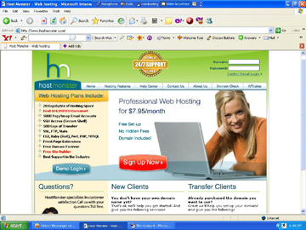
Our ratings
Price Value 8.5 / 10
Performance 9 / 10
Reliability 8.5 / 10
Customer Support 9 / 10
Control Panel 8.5 / 10
User Feedback 9/ 10
Overall Grade: 88%
Top Pick
Highest customer service, quality equipments, maximum guaranteed uptime, highly functional tools for administration, the leading feature set available, secure and reliable backups, slid and honest business practices are some of the top reasons to choose Host Monster.
Price Value
HostMonster offers Professional Web Hosting, with unlimited domains in one account for $7.95/mo. with 20 GB space and 500 GB site transfer, for new, as well as transfer sites. This package gives you all the features required to host your personal website or small business site and gives the flexibility and space you need to inflate at no extra price. This hosting plan includes a free drag and drop site builder, support of international domain names, unlimited POP3 email support, equipped Marketing Centre, any number of Shopping Carts, Mambo & Joomla, free Search Engine Submitter, Agora Shopping cart, unlimited parked domains and subdomains. You'll get CGI-BIN, MySQL, and Perl and PHP support. Your package also comes with such multimedia features as streaming audio-video, Real audio-video support, Flash and Macromedia support; besides FrontPage 2000/2002/2003 extensions, Website Statistics, guestbook, bulletin board, image gallery, chat rooms, and blogger. HostMonster uses cPanel as their backend and that is second to none. cPanel is the backend chosen by the majority of webmasters that are in charge. Fantastico is one click excellent tool for dozens of pre-installed scripts you may require as well such as blogs, forums, guest books, shopping carts and form generators.
Affiliate Program
To take the maximum benefits from HostMonster, and make some additional income, join the Affiliate Program of HostMonster and get $95 for every valid customer who becomes a paid member of HostMonster.com. by clicking on their banner / advert placed on your site. Through your personal affiliate login to the online administration and you can:
- View click-through ratios of your links or banner promotions to HostMonster.
- View payments by sign-up
- Download your personalized tracking code
- Track your commission payouts

Reliability
Usage of high performance Quad Opteron servers, customized Apache web server, 24/7 monitering, mirrored storage backups, OC-48 backbone connection show that HostMonster takes your data security very seriously. Their systems include high power UPS generator electrical backup, closed circuit monitoring and air-conditioning systems. Their wide spread hardware infrastructure and additional systems enable them to provide solutions that are of the highest possible speed and quality.
Their Mailing Address
HostMonster, Inc.
1548 North Technology Way #D13
Orem, UT 84097
Their hosting solution comes with a unique 99.9% uptime guarantee.
Customer support
HostMonster offers 24/7 customer support in a number of convenient ways. Their call center number is (866)-573-4678 / 866)-573-HOST (801-494-8462 for customers from outside US). But just before calling, you can preferably have a live online chat with their technical support executive and sales support team using ‘My Account’ feature. Else, you can send your queries, and problems to them using their ticket system, which they reply shortly. But even before that, you can as well check out the ‘knowledgebase’ question-answers for your type of problem and it’s solutions, and there are good chances, that you will find your solution.
Hosting Plans
Linux/Unix Hosting Plans
Professional Hosting Plan: 20000 MB disk space, 500 GB bandwidth at $7.95/month (hosting unlimited domains).

Site Review-7
POWWEB
Trusted by 60,000 satisfied customers, since 1999, who have given excellent feedback, Powweb has established it’s brand name as one of the leading ‘low cost’ hosting options for small to medium sized business. Awards such as, Hosting-Review.com Top Pick 2005-Best Business Hosting, FindMyHost.com Editor’s Choice, To 25 Web Hosts-RateMyHost.com; to name a few, have added extra dimension to their company profile. They offer a 30 day money back guarantee, coupled with 99% infrastructure availability.
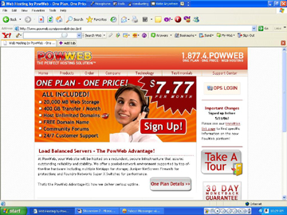
Our ratings
Price Value 9/10
Performance 8.5 / 10
Reliability 8.5 / 10
Customer Support 9 / 10
Control Panel 9 / 10
User Feedback 9.5 / 10
Overall Grade: 89%

Top Pick
Powweb include such grand features as:
- Rates starting from $7.77/mo
- 20,000 MB web storage
- 400 GB transfer/mo
- hosting UNLIMITED domains
- FREE Domain
- Community forums
- 24/7 customer support
- 30 Day Money Back Guarantee
With such power packed features included; competing with Powweb.com will not be child’s play for other hosting sites.
Value for money
At just $7.77/mo you can get Powweb’s OnePlan Package having features as 20GB storage, 400 GB transfer/mo, free setup, free domain, hosting unlimited domains in 1. Other features included are-- Member Operations Control Panel, DNS Management (A records, Cnames, MX records), Sub-Domains (something.yourdomain.com), Free easy to use site builder, 24/7 FTP Access, 10 FTP Users (separate directories), Web-Based FTP File Manager, Site Manager, FrontPage 98/2000/2002 Extensions, PHP4 & PHP5 w/Zend Optimizer, Perl5, Sendmail, Flash, Shockwave, Midi, Multimedia Support, Unlimited Mailboxes (POP3/IMAP & SMTP), Unlimited E-mail Forwarding/E-mail Aliases, Built-in OsCommerce Shopping Cart, SSL - Shared Secure Certificate, Accept Paypal Payments
Affiliate Program
(a) Affiliates:
If you are interested to make some additional income, join the Affiliate Program of Powweb and get $77.77 for every confirmed new buyer you send to Powweb.com Powweb.com's affiliate program gives you all the tools you'll need to earn money!
- They provide you with pre-made banners and links that promote our hosting services.
- They put them on your Web site or include them in your e-mail.
- They pay you for each new customer you refer to us.
- Check your stats and commissions at any time to see how you're doing.
(b) Refer 3 friends and your hosting becomes free
If you are satisfied with the services of Powweb.com, spread the word; and you receive a commission of $15 for each such referral.
How it works
- Tell your friends about our great hosting plans.
- When people you refer sign up for a Web hosting account, ask them to enter your domain or user name in the "Referred by" field. They can also call to sign up; just have them let us know your domain name or username when they call.
- After your referred account has been with PowWeb Web Hosting for 30 days, you will recieve an e-mail letting you know that we have credited your account with the amount of $15.
Customer Support
Powweb offers 24/7 X 365 customer support in a number of customer friendly ways. Their toll free call center number is 1-877-4-POWWEB / 877-476-9932. But why call, when you can have a live chat with their technical support executive, and sales support team, or send your queries, and problems to them via email, which will be replied soon, by email. But before that you can check out the FAQ questionbank, and the knowledgebase, for answers to common problems encountered, and maybe, you will find your answer, without having the need to do anything more. Besides all these, their community forums bring you face to face with other members, who might have your solution. Online tutorials will help you comprehend things. You can get downloads, external links, and other valuable resources. You cahn send your feedback and suggestions and they are much valued by Powweb.
Reliability
PowWeb has been providing award-winning hosting since 1999. They operate out of a real office with real staff monitoring their servers and network 24/7. PowWeb is a member of the Better Business Bureau and has agreed to the Bureau's membership standards, which include a commitment to ethical business practices
Powweb’s servers connect to the Internet at lightning speed! Their backbone includes high speed OC12/48 connection for efficient and reliable high-speed performance. They have teamed up with a major connection tier 1 provider to bring you one of the most reliable services on the Internet today.
Take advantage of the latest technology. Thanks to their "load balanced" servers, your Web site will experience virtually no downtime during server reboots, server maintenance and server hardware failure. Powweb distributes the load of a single web site across multiple physical servers. If one server goes down, there is no noticeable effect on end users and no downtime.
Hosting Plans
Unix Hosting Plans
One Plan: 20,000 MB disk space, 400 GB bandwidth at $7.77/month (hosting unlimited domains).

Site Review-8
AN HOSTING
Trusted by thousands of satisfied customers in more than a hundred countries, since early 2001, who have given excellent feedback, AN HOSTING has grown from a small no-name out of Chicago sub-hub company over the years to establish it’s brand name and win the trust of its users. Now having three offices in two countries, and a staff strength of 30, they have won awards such as, Best Unix Web Hosting Company in July 2006, Editors Pick award from Hosting Review-2006; to name a few. They offer a 30 day money back guarantee, coupled with 99.9% uptime guarantee.
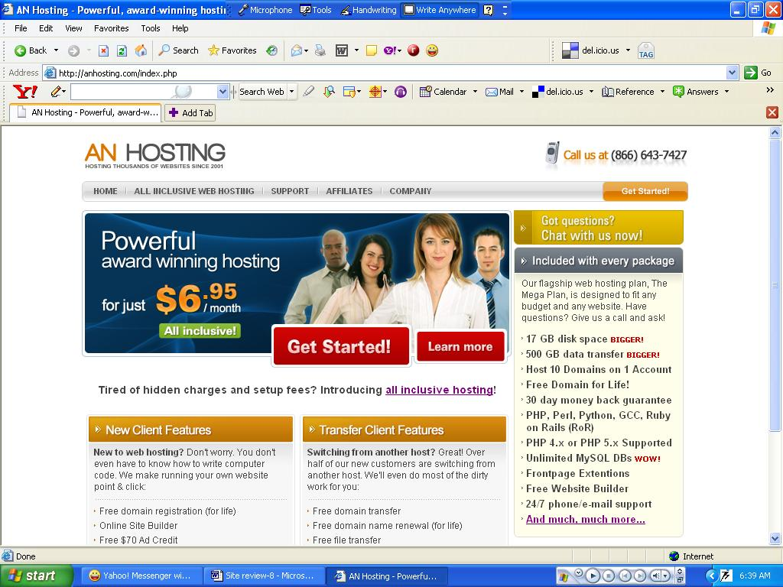
Our ratings
Price Value 9/10
Performance 8.5 / 10
Reliability 8.5 / 10
Customer Support 8 / 10
Control Panel 9 / 10
User Feedback 9/ 10
Overall Grade: 87%

Top Pick
AN HOSTING include such grand features as:
- 17 GB disk space (BIGGER than before)
- 500 GB data transfer (BIGGER than before)
- Host 10 Domains on 1 Account
- Free Domain registration for Life
- 30 day money back guarantee
- PHP, Perl, Python, GCC, Ruby on Rails (RoR)
- PHP 4.x or PHP 5.x Supported
- Unlimited MySQL DBs
- Frontpage Extentions
- Free Website Builder
- 24/7 phone and e-mail support
With such mind-blowing features included; the fight with AN HOSTING will definitely be tough for others.
Value for money
At just $6.95/mo you can get AN HOSTING MegaPlan Package having features as 17GB storage, 500 GB bandwidth, free setup, free domain, hosting 10 domains in 1 account. Other features included are—2000 FTP accounts, unlimited MySQL database, 9 addon and 10 parked domains, unlimited sub domains, unlimited email accounts and auto responders, IMAP, POP3, developers’ support like--SMTP Support, PHP, MySQL, Ruby on Rails (RoR), Python, CGI-BIN, CGI Library, Full .htaccess Control, Server Side Includes, Custom CRON Jobs, MIME Types, and IP Banning. First timers’ support includes such features as--Fantastico (Lots of free scripts), Easy to use, point-and-click website builder, Blogging Tools (Including WordPress and Mambo), GuestBook, PHP Nuke, FormMail, Image Gallery, PHP BB and more, besides Online Form Builder. E-commerce features included are; OS Commerce Shopping Cart, Agora Shopping Cart, Cube Cart Shopping Cart, Zen Cart Shopping Cart, Free $70 Ad Credit, Free Self-Signed SSL Certificates, Webalizer, Sub-domain Stats.
Affiliate Program
If you are serious about making money, join the Affiliate Program of AN HOSTING and get $85 to $100 for every confirmed new buyer (paid every 2 weeks) you send to anhosting.com AN HOSTING’s affiliate program features are as follows:
- Dedicated affiliate manager
- Online and real-time reporting
- They pay you every two weeks like clockwork
- You have the option of promoting some of their other high converting brands.
The affiliate helpline/contact number is 312-386-1642
Customer Support
AN HOSTING offers 24/7 X 365 customer support via MP customer in 3 customer friendly ways. Their call center number is (866)-643-7427. You can talk regarding billing and technical support. But why call, when you can send your queries, and problems to them via email, which will be replied soon, by email. Alternately you can use their ticket system, which is similar to e-mail and get technical and billing solutions.
Reliability
AN HOSTING, the Chicago based company has been providing award-winning hosting since EARLY 2001. Their Cisco Powered Network of Dual Core Dual Operation Services, running in SCSI, RAID-5 Technology, have the benefit of UPS backups and diesel generator backup. The datacenters are completely fitted with redundancy for precision HVAC, power and fire detection/suppression systems, etc. Security features of their data center include: Center is manned by on-site security on a 24x365 basis, all doors, including cages, are secured with biometric hand geometry readers, IBX exteriors are fully anonymous and have no windows, CCTV digital camera coverage of entire center, including cages, with archival system, all exterior walls are bullet resistant, entire perimeter bounded by concrete bollards/planters, a silent alarm and automatic notification of appropriate law enforcement officials, protect all exterior entrances, CCTV integrated with access control and alarm system, motion-detection for lighting and CCTV coverage, all equipment checked upon arrival, shipping and receiving area walled off from collocation areas.
Hosting Plans
Unix Hosting Plan
Mega Plan: 17,000 MB disk space, 500 GB bandwidth at $6.95/month (hosting 10 domains in 1 account). Control panel—cPanel.

Site Review-9
HOST EXECLLENCE
Hosting 20,000 domains in US and 90 other countries, HostExcellence maintains strategic relationships with leading Internet related service companies including CyberCash, who facilitate real-time credit card processing over the Web and NSI, who ensure customers' domain name services are handled as fast as possible. HostExcellence is constantly looking for new and better ways to help its customers build their businesses on the Internet. Members of HostExcellence can run upto 15 domains having 1 web hosting account. HostExcellence is the proud winner of awards like Top 2 ranking overall with The Hosting Chart.com (for the 3rd year in a row), "Host Excellence" 2005 Most Affordable Hosting, by Hosting review, and more. HostExcellence offers their members a wide range of options to choose from, with prices ranging from $2.95/mo to $14.95/mo.

Our ratings
Price Value 9.5 / 10
Performance 9 / 10
Reliability 8.5 / 10
Customer Support 9 / 10
Control Panel 8 / 10
User Feedback 9 / 10

Overall Grade: 88%

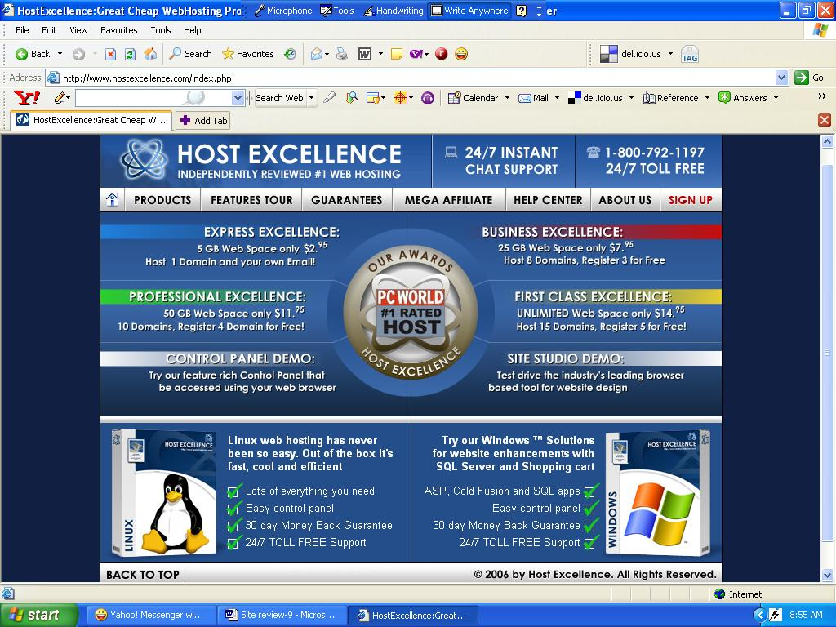
Top Pick
Cost effective prices
Range of 4 options to choose from
5 guarantee in 1:
- 30 days money back (trial period)
- Any time full refund if unsatisfied (you don’t have to drag the subscriptiuon)
- Price freeze guarantee (no hike in price during contracted period)
- Support within 1 hour—guarantee
- 99.9% uptime guarantee

Price Value
1. HostExcellence hosting plans start with Express Plan for shared hosting at 5 GB space, 50 GB bandwidth, 1 domain, 20 sub-domains, 1000 POP3/IMAP Mailboxes, guarantee bundle @ $2.95/mo (2 yr plan), for beginners, or for those, whose site requirements are limited.
2. HostExcellence offer their second plan, the Business Plan, that features 25 GB of disk space, 300 GB bandwidth, 8 domains with 3 FREE domains, 300 sub-domains, 10,000 POP3/IMAP Mailboxes, guarantee package; all @ $7.95/mo.
3. Their third plan is the Professional Plan, which offers 50GB disk space, 400 GB bandwidth, 10 domains with 4 FREE domains, 500 sub-domains, 20,000 POP3/IMAP Mailboxes, guarantee package, FREE setup @ $11.95.
4. Their 4th plan, named as 1st class Plan, offers an unbelievable unlimited disk space, 500 GB bandwidth, 15 domains with 5 FREE domains, 1,000 sub-domains, UNLIMITED POP3 / IMAP Mailboxes, UNLIMITED FTP User Accounts (Windows 1 only), UNLIMITED Aliases, Forwards & Responders, guarantee package, FREE setup, @ $14.95/mo.

Host Excellence Affiliates
To take the maximum benefits from HostExcellence, and make some additional income, join the Affiliate Program of HostExcellence and get $100 for every valid customer who becomes a paid member of HostExcellence.com. by clicking on their banner / advert placed on your site. Earning is unlimited with a quality product like HostExcellence.
Reliability
The backbone of HostExcellence’s infrastructure is an unparalleled high-performance server network-specifically designed to provide the capacity, redundancy and scalability you need for optimum Internet site performance. Their network is managed to have excess capacity when you need it. They use redundant fibre paths, so there is no single point of failure in our backbone. At the heart of any good corporation are dedicated people, sound processes and effective technology. Their customers appreciate and will gladly attest to the high level of professional and personal care they receive when dealing with Host Excellence. Operating 24x7x365, their NOC technicians are trained and equipped to troubleshoot and resolve virtually any problem. HostExcellence boasts of top-of-the-line ISP grade equipment with manageable, scalable and most of all stable servers, routers and switches in the industry! Their team of skilled experts is completely focused on delivering the highest levels of administration and networking support. These support organizations are divided into two groups; the Provisioning group which coordinates customer requests, web hosting account set-ups and new technology roll-outs and the Network Operations Centre (NOC) group which handles direct customer support and monitoring of Host Excellence’s internal infrastructure. Both groups include highly experienced network engineers and systems administrators who work with customers from beginning to end, right through to the maintenance and support of their website functionality. These network engineers and system administrators are trained specialists who support Windows NT, Windows 2000, Linux and other UNIX platforms. They are Internet experts with years of experience supporting and operating routers, switches and other Internet infrastructure equipment.
Their worldwide offices are at:
United States
Ecommerce Corporation
247 Information Highway Ln
Hopkinsville, KY 42240
European Union
Ecommerce GmbH
Neuhoferstr. 1
A-4240 Freistadt, Austria
India
Hosting Network India Private Ltd.
12 Journalist Colony, Road No 3
Banjara Hills, Hyderabad - AP 500034
Control Panel
HostGator uses fast, reliable, user friendly REAL TIME control panel with features like:
Multiple Domain Management
Add and remove Domains in Real-Time!
All Domains having full Email Services,
FTP, FrontPage - fully functional Hosting!
Real-Time Email Management
POP3, IMAP & WebMail support
Add or remove email addresses, aliases,
Mailing lists, auto responders & catch-all
Manage mail quota & mailbox passwords
FTP Access Management (only Linux Plans)
Manage Virtual FTP Server for each domain
Add virtual FTP sub-users for each domain
Change FTP account passwords
Manage your anonymous FTP Server!
Password Protected Directory Manager
Manage protected directories in real-time!
Create, delete and manage usernames & passwords!
Customer support
HostExcellence offers 24/7 customer support in a number of convenient ways. Their toll-free 24 hrs call center number is 1-800-792-1197, always ready to give you technical and billing support. Besides calling, you can preferably send your queries, and problems to them via email using their ticket system, which they reply shortly, by email. Before that you can always check out the FAQ databank for questions and solutions, and 99% chances are, you will find your solution there, and will have to look no further. Another option is download their user manual and get complete solutions and hints for your queries, HTML references.
Hosting Plans
Linux/Unix & Windows Hosting Plans
Express: 5 GB disk space, 50 GB bandwidth @ $2.95/month
Business: 25 GB disk space, 300 GB bandwidth @ $7.95/month
Professional: 50 GB disk space, 400 GB bandwidth @ $11.95/month
1st class: Unlimited disk space, 500 GB bandwidth @ $14.95/month
Site Review-10
IX WEBHOSTING
Since 1999, IX WebHosting has been providing first-class web hosting services to 80,000 customers. They are a subsidiary of the Ecommerce Corporation (www.ecommerce.com), a global company with offices located on nearly every continent. Regardless if you are a small business, medium-sized or large corporation or if you just need a private website: IX Web Hosting has a solution for you.

Members of HostExcellence can run upto 10 domains having 1 web hosting account. Hosting-Review.com has selected IX Webhosting as its 2005 Best Cheap Hosting Award winner. IX Webhosting has been voted as the #1 reviewed Web Hosting Company by TheHostingChart.Com.

ixwebhosting.com offers their members a wide range of options to choose from, with prices ranging from $3.95/mo to $14.95/mo.

IX WEBHOSTING makes a strong promise of a 30 day 100% money back guarantee. Now, what does it mean? The majority of all hosting companies only offer a partial 30-day money back guarantee. Either they won't refund your setup fees, or the current month, or charge a "cancellation" fee, or even not honor their money-back guarantee at all! With IX Web Hosting, you can rest assured that you will receive a 100% refund of all fees paid - including setup fees - if you request your money back within the first 30-days of your account (less any over-usage costs). Don't take their word for it - read their terms of service, where they legally agree to refund 100% of your money including setup fees. Their any time money back guarantee promises you a full refund of the current month’s full subscription, plus the subscription of the unused months, if you cancel their membership at any point of time. Additionally you get a price freeze guarantee—no hike in price during your membership period.

Our ratings
Price Value 9.5 / 10
Performance 9 / 10
Reliability 8.5 / 10
Customer Support 8 / 10
Control Panel 8 / 10
User Feedback 9 / 10

Overall Grade: 87%

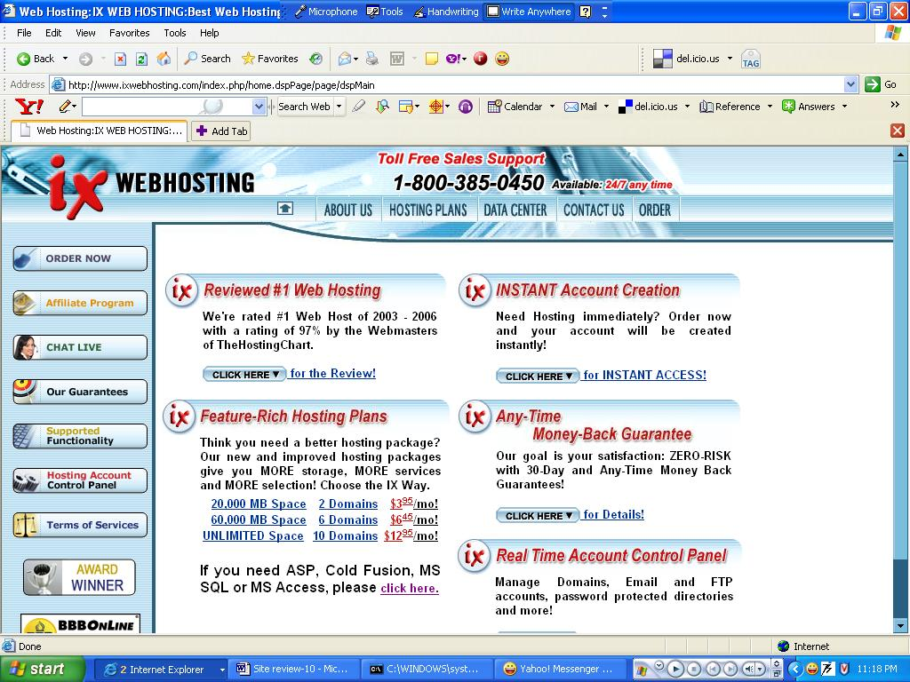
Top Pick
IX WEBHOSTING offers such interesting features as:
- 100% 30-Day Money-Back Guarantee
- Any-Time Money Back Guarantee
- Price-Freeze Guarantee
- 99.9% Uptime Guarantee

Price Value
1. IX Expert Plan is for low budget hosting at 20 GB space, 250 GB bandwidth, 2 domains (1 free), 20 sub-domains, 2,500 email accounts, guarantee bundle @ $3.95/mo 2. IX Business Plus offers features like 60 GB of disk space, 500 GB bandwidth, 6 domains with 3 FREE domains, 200 sub-domains, 5,000 email accounts, guarantee package; all @ $6.45/mo.
3. Their third plan is the IX Unlimited Pro, which offers unlimited disk space, 1000 GB bandwidth, 10 domains with 5 FREE domains, 500 sub-domains, Unlimited email accounts, guarantee package, FREE setup @ $12.95.
4. Their Windows IX Business Win Plan, offers 60 GB disk space, 500 GB bandwidth, 6 domains (3 FREE domains), 200 sub-domains, 5,000 email accounts, @ $8.95/mo.
5. Their Windows IX Unlimited Win Plan gives you unlimited web space, 1000 GB bandwidth, 10 domails (5 FREE domains), unlimited email accounts, 500 subdomains, guarantee package, @ $14.95.
All IX Hosting plans support CGI-BIN, Perl 5, CGI-scripts, PHP 4 scripting, Microsoft FrontPage and Macromedia DreamWeaver, Flash, and ShockWave, Real Media, MP3s, Quicktime, streaming audio, MySQL, PostgreSQL, Webalizer and ModLogan statistics, WAP (Wireless Application Protocol). ColdFusion, Microsoft SQL servers and Active Server Pages supported by only Windows packages.

Affiliate Program
Now here is more good news. Did you know that some of the top affiliates of IX WEBHOSTING are earning more than $10,000/mo? Interested? Without a second thought you can join the Affiliate Program of IX WEBHOSTING and get $90 for every referral of ixwebhosting.com, whether you are their member or not. It is absolutely FREE of any charges, and there is no limit of the number of referrals you can make/send. Earning is unlimited with a quality product like IX WEBHOSTING.
Reliability
IX Web Hosting operates its own data centre in Hopkinsville, KY. Currently, over 750 servers are in operation – they are adding daily. They own and maintain all our equipment and do not collocate in any third-party facility. Their 80,000 customers are addicted to their reliability and speed of service, partly because of their redundant connectivity, featuring CISCO 12000 series routers and SONET reliability.
IX WEBHOSTING gives top priority to the uptime of their customers. And that is why they run their network from fault-tolerant systems, utilize smart-routing to ensure "speed of light" loading time, and provide utmost redundancy at any time. The actual configuration of any of their servers is like this:
WEB7's Configuration:
Make: Dell PowerEdge 2650
Processors: DUAL Intel Xeon 2.8GHz, 512K Cache
Technology: Hyper Threading, 533MHz Front Side Bus
Memory: 6.0GB DDR at 266MHz Frequency
Redundant AC Power: 2x500 Watt Power Supplies
Hard Drives: 5x146GB 10K RPM Ultra 320 SCSI
Total Capacity: 730GB working redundant via RAID5
Networking: Intel Pro 1000MT Dual Port Gigabit
Operating system:
Linux version 2.4.22, (Red Hat Linux 7.3 2.96-110)
(root@web7.ixwebhosting.com)
Their United States Office (Network Operations Center)
IX Web Hosting
247 Mitch Lane,
Hopkinsville, KY 42240,
United States
Toll Free: 1-800-385-0450 (24/7 - any time - day or night)

Control Panel
IX WebHosting's proprietary H-Sphere control panel is extremely user friendly, chiefly because an all icon-based interface. Find out what the icons of the control panel signify, and the rest is child’s play. The best features of this panel are multiple domain management, real-time email management (autoresponders included), and a password protected directory manager.
Customer support
IX Web Hosting is all about people. You will always get a HUMAN response from them on any request or issue that you may have and will be assisted as fast as humanly possible - with a 1-Hour Response Guarantee!
They have a low-price philosophy while providing a high level of service by extremely skilled engineers. You will be assisted by over two dozen well-trained customer service specialists who can assist you with all your needs, as they do NOT outsource their support responsibility to third-party companies who do not care much about the individual customer.

IX WEBHOSTING offers 24/7 customer support in a number of convenient ways. Their toll-free 24 hrs call center number is 1-800-385-0450, always ready to give you technical and billing support. Besides calling, you can preferably send your queries, and problems to them via email using their ticket system, which they reply shortly, by email, or choose their live chat option.
Hosting Plans
Linux/UNIX Hosting Plans
Linux Hosting IX Expert Plan: 10 GB disk space, 250 GB bandwidth @ $3.95 per month (host up to 2 domains)
Linux Hosting IX Business Plan: 20 GB disk space, 500 GB bandwidth @ $6.45 per month (host up to 6 domains)
Linux Hosting IX Unlimited Pro Plan: unlimited disk space, 1000 GB bandwidth @ $12.95 per month (host up to 10 domains)
Windows Hosting Plans
IX Business Win Plan: 20 GB disk space, 500 GB bandwidth @ $8.95 per month (host up to 6 domains)
IX Unlimited Win Plan: Unlimited disk space, 1,000 GB bandwidth @ $14.95 per month (host up to 10 domains)
Poker site review -1
PartyPoker.com
Overview
PartyPoker, a division of Party Gaming, is not the no1 online poker site without any reason. Every month their players win over $250 million in online tournament prize pools, they deal over 10 million hands a day in 185 countries, boast of the greatest selection of games and limits-- Texas Hold’em, Omaha, 7 Card Stud. Their whooping 17 million plus players is definitely a real cause of envy for their competitors.


First Impression
PartyGaming, the mother organization of PartyPoker.com, started in 1997 and has established its brand name as the leading online gaming company, listed in London Stock Exchange. Poker, Casino and Bingo are their three major specialization areas.
Perhaps the best poker room on the net. Finding a game and opponents is not at all difficult. Incidentally it shares its games with Empire Poker. That also happens to be a reason why finding players is easy. Very user friendly. Superior graphics. Tutorials are also the best, and will teach a layman the art of gaming in minutes. Though bonuses are lesser than other sites, but with game points one can buy merchandise.

Player Traffic
PartyPoker shares players and games with Empire Poker. This is why it is easy to find opponents to play with. PartyPoker has an unbelievable 17 million registered members, of which active players of poker are 14.0 million a 23% rise from 2005 when the figure was 11.4 million (PartyPoker earns a net daily revenue of $2.7 million per day now, as campared to $2.1 million in 2005).
Features
Games and Table Stakes
Party Poker offers these games: Texas Hold'em, Omaha High, Omaha 8 or Better, 7 Card Stud, and Stud 8 or Better. Table stakes are as follows:
Texas Hold'em Games: fixed limit tables ($0.50/1 to $30/60 blinds), pot limit ($0.25/0.50 to $2/4 blinds), no limit ($0.25/0.50 to $2/4 blinds).
Omaha & Hi-Lo Games: fixed limit tables ($0.50/1 to $20/40 blinds), pot limit ($0.25/0.50 to $1/2 blinds).
7 Card Stud Games: fixed limit tables ($0.50/1 to $20/40 blinds).
Tournaments
Party Poker hosts a number of limit, no limit, and pot limit tournaments (real money and/or play for fun). Their greatest tournament is the once a year Party Poker Million tournament, the finals of which are held on a luxurious cruise. They also hold regular (single-table and multi-table) Sit and Go Tournaments and huge multi-table tournaments. Also worth mentioning is The World Series of Poker 2006.

Bonuses
Party Poker offers $25 free on your first deposit, or a welcome bonus of 20%, up to $100 on your 1st deposit.
Software
PartyPoker.com’s software platform is one of the most sophisticated, yet easy to use, platforms on the web. They have been constantly updating their software to ensure better customer satisfaction. Additionally, their systems are supported by over 100 technical support professionals who provide round-the-clock support to the customers worldwide. Installation and login procedures are user friendly. Graphics are superior and quicker than their competitors’. Rarely hangs. The lobby is tempting, and one can easily navigate between games.
Support
PartyPoker offers 24/7 customer support by (a) phone (b) email (c) FAQ
- Their 24 hours toll free numbers are:
1-800-852-4719
011-800-7789-7537
(USA and Canada)
00-800-7789-7537
00-800-PRTY-PKER
(UK, Rep. of Ireland, Spain, France, Belgium, Netherlands, Germany, Denmark, Italy, Switzerland, Sweden, Luxembourg, Hungary, Poland, Norway, Portugal)

Their 24 hours toll numbers are:
+1-800-852-4719
+44 -207- 537- 8300
+350-50509
- They promise support and assistance by email within 24 hrs of receiving your email. For general information you can mail to info@partypoker.com. They have many other email addresses for specific queries.
- But even before you call them or email them, you can try browsing through their dozens of FAQ questions and answers.

Security
PartyPoker uses sophisticated software and monitoring technology to ensure that proper security is always maintained.

Transaction Security
All transactions on PartyPoker are protected by the topmost level of encryption. For this, their online payment center uses 128-bit encryption technology and Secure Socket Links (SSL) to ensure the security of each and every transaction, and also ensuring the confidentiality of all data. Financial transactions are conducted according to applicable laws and the standards of the international banking community.

Account Security
- Accounts of players accessible only via unique username and password.
- Only one account per player. Security team randomly verifies genuinely of name and address, and closes accounts of unreal members.
- PartyPoker.com offers its players the highest level of support in the industry. They give instant response to questions on any security issues.

Game Security:
- Before each hand is dealt, a sophisticated random number originator shuffles the cards.
- All game information is transmitted between the PartyPoker.com servers and players' computers via 128-bit encryption and a secure socket link (SSL).
- It is impossible for any player to use technology or tricks to see another player's cards.
- The PartyPoker.com security team monitors and reviews hand histories and data to stop involvement among players.
Banking
A host of options open to fund your account. Choose from-- Visa, MasterCard, Diner’s Club International, Neteller, Wire Transfer, Usemybank, FirePay, Citadel, PayPlay, MoneyBrokers.com.
Final Summary
By far the best option for poker fans, no doubt, especially considering the traffic flow, and the ease with which you can find the games and opponents. A variety of payment options (PayPal is however not included) to choose from. Secure account. Fast game graphics. Tempting lobby. Huge tournaments. Winning an amount is not a big deal, if you hang on for sometime.

